Calculator Free
Non-Linear Functions

Time: 45 minutes
Total Marks: 45
Your Score: / 45



Question One: [2, 2, 2, 2 = 8 marks]

From the above list of functions and relations, state all those:

- representing a cubic function.

- representing polynomial functions.

- representing reciprocal functions.

- whose graphs have domains that do not exist for all real values.

Question Two: [1, 5, 2 = 8 marks]
- Show that is a factor of

- Hence factorise and state the other two factors.

- Using your results from (a) and (b) determine the roots of the function .

Question Three: [2, 3, 1, 1 = 7 marks]
- Represent in the form

- Represent in the form

- State the degree of the polynomial given in part (b).

- State the coefficient of the x term in part (a).

Question Four: [2, 2 = 4 marks]

- Sketch the graph of on the axes below.
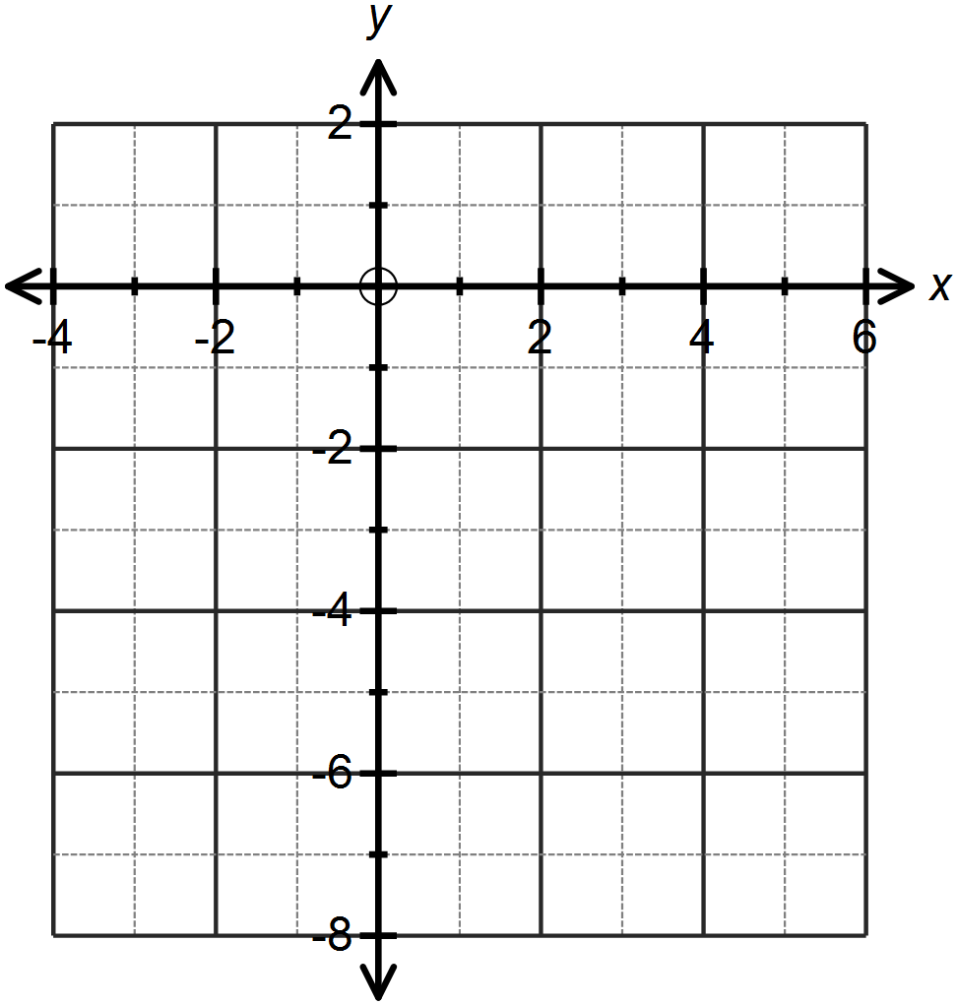

- Explain, using the vertical line test, why your graph does not represent a function.

Question Five: [2, 2, 2, 2 = 8 marks ]
- Sketch the function on the axes below.
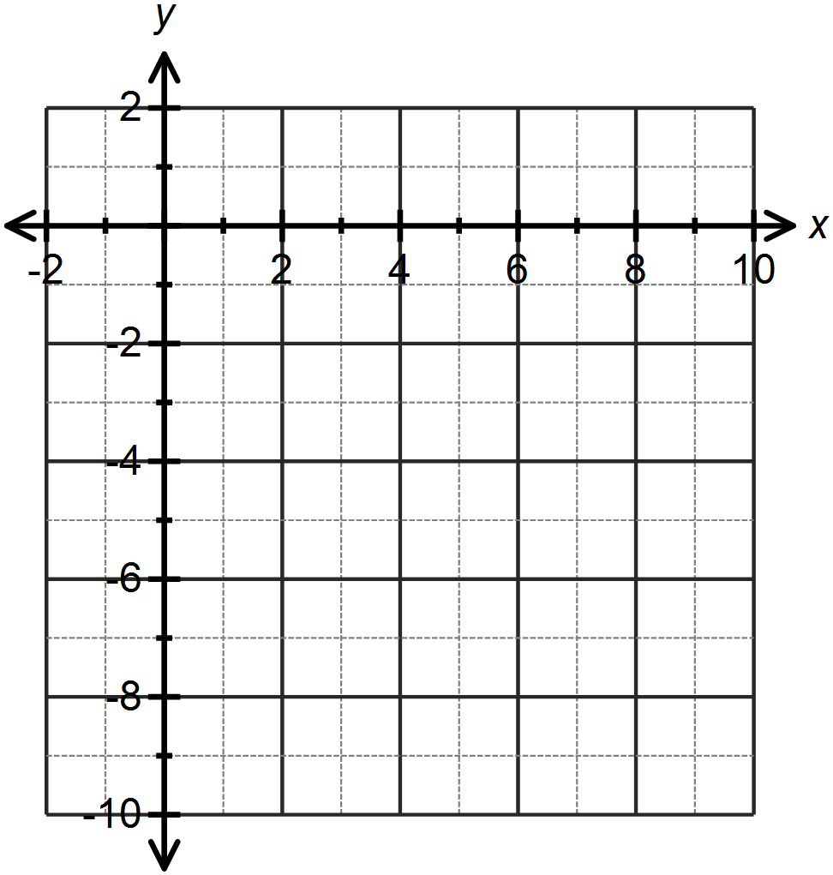

- Sketch the function on the set of axes above.
- Write an equation which represents the combined relationship of the two graphs drawn.

- Does your equation in part (c) represent a function? Explain your answer.
Question Six: [2, 8 = 10 marks]
- Consider the function .
Over what domain would this function represent the following context: The number of hours required to lay bricks with x bricklayers.

- Consider the function .
Determine:
- The equation of the horizontal asymptote.

- The equation of the vertical asymptote.

- The coordinates of the x and y intercepts.

- The behaviour of y as

- The equation, in terms of x, of the function

SOLUTIONS
Calculator Free
Non-Linear Functions

Time: 45 minutes
Total Marks: 45
Your Score: / 45



Question One: [2, 2, 2, 2 = 8 marks]

From the above list of functions and relations, state all those:


- representing a cubic function.


- representing polynomial functions.



- representing reciprocal functions.



- whose graphs have domains that do not exist for all real values.


Question Two: [1, 5, 2 = 8 marks]
- Show that is a factor of

- Hence factorise and state the other two factors.






- Using your results from (a) and (b) determine the roots of the function .


Question Three: [2, 3, 1, 1 = 7 marks]
- Represent in the form



- Represent in the form





- State the degree of the polynomial given in part (b).


- State the coefficient of the x term in part (a).


Question Four: [2, 2 = 4 marks]

- Sketch the graph of on the axes below.
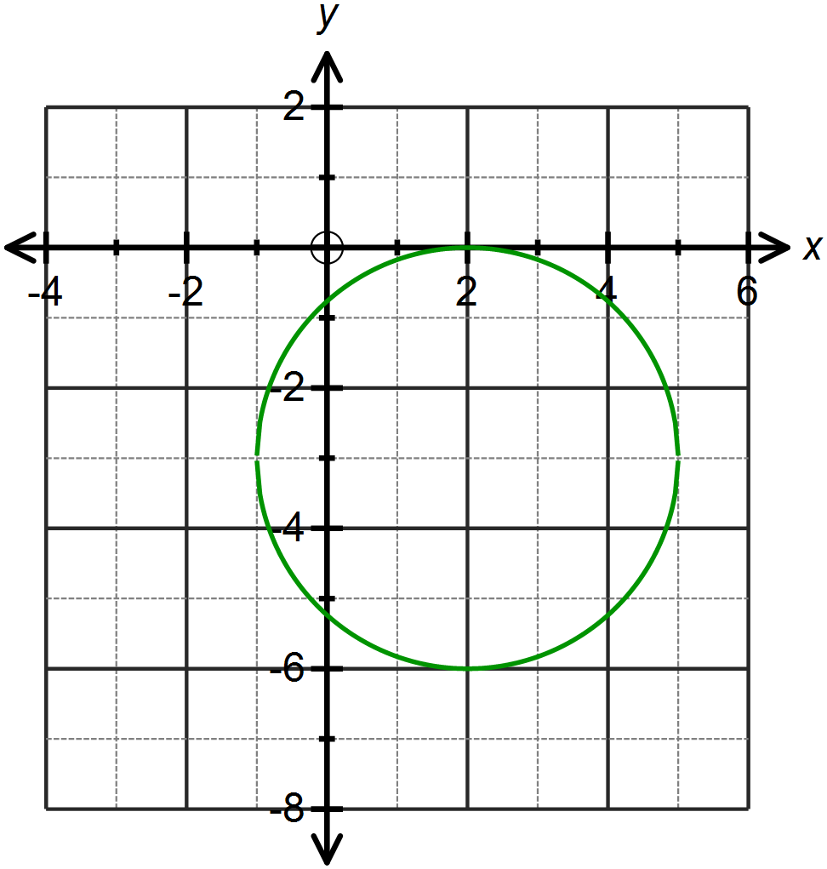





- Explain, using the vertical line test, why your graph does not represent a function.

On the interval -1 < x < 5, a vertical line through the graph shows that for every x value there are two y values and thus this is a 1 – to – many relationship and hence not a function.
Question Five: [2, 2, 2, 2 = 8 marks ]
- Sketch the function on the axes below.
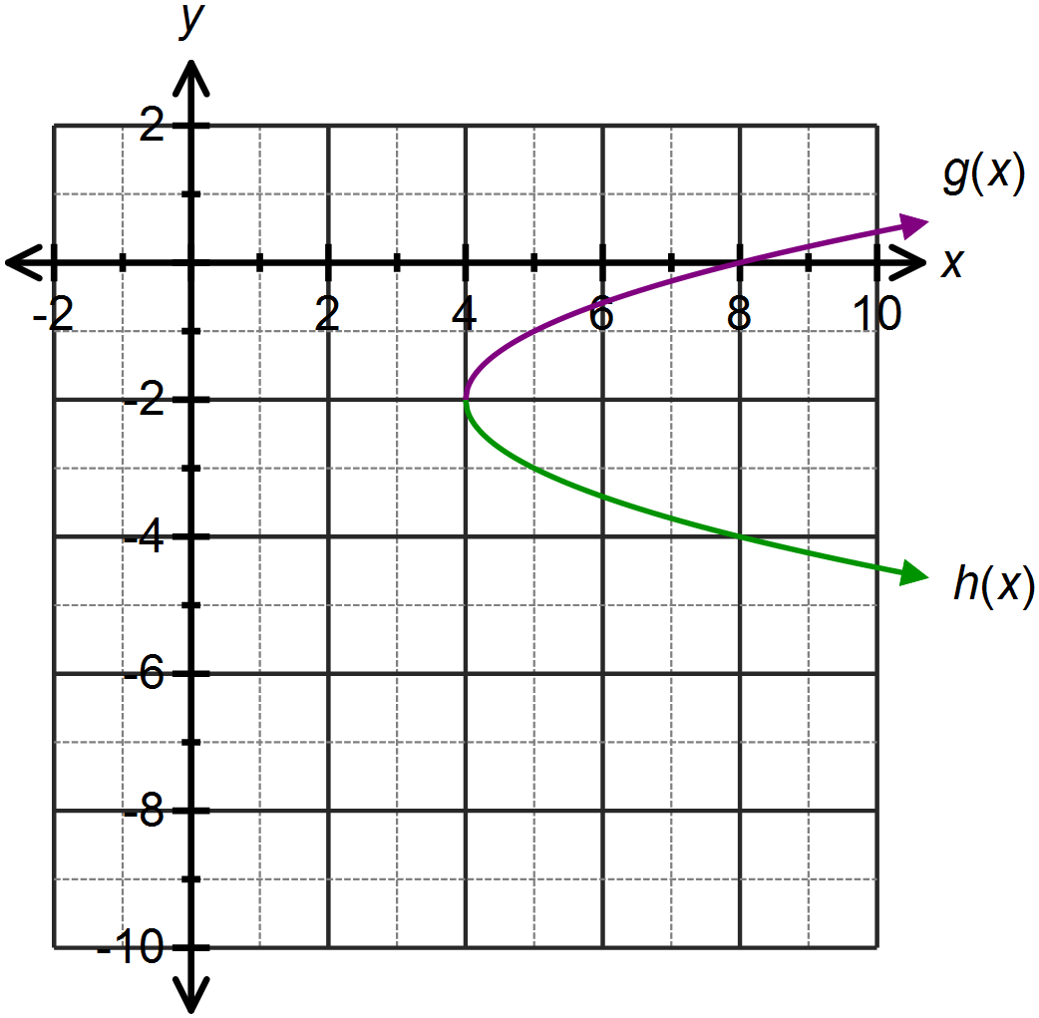








- Sketch the function on the set of axes above.
- Write an equation which represents the combined relationship of the two graphs drawn.




- Does your equation in part (c) represent a function? Explain your answer.

No. The graph of this relationship, as shown above, fails the vertical line test and has more than one y value for each x value.
Question Six: [2, 8 = 10 marks]
- Consider the function .


Over what domain would this function represent the following context: The number of hours required to lay bricks with x bricklayers.
- Consider the function .
Determine:

- The equation of the horizontal asymptote.
- The equation of the vertical asymptote.


- The coordinates of the x and y intercepts.





- The behaviour of y as
- The equation, in terms of x, of the function



